**Week 1: Python Basics & Programming Foundations**

**1. Introduction to Python & Setup**

**Task: Install Python & VS Code**

**Steps:**

1. Download Python from [https://python.org](https://python.org" \t "_new)
2. Install with “Add Python to PATH” checked.
3. Install VS Code from https://code.visualstudio.com
4. Open VS Code > Install Python Extension (ms-python.python)
5. Create hello.py and add:  
   print("Hello, Python World!")
6. Run using:
   1. Terminal: python hello.py
   2. Or Click ▶ Run in VS Code

**Output**

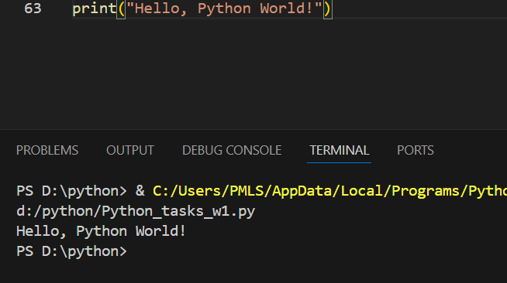

**2. Python Syntax: Indentation, Comments, Variables**

**Task: Write clean code using proper syntax**

**Code:**

# This is a comment

name = "NAME" # Variable: string

age = 25 # Variable: integer

height = 5.9 # Variable: float

# Proper indentation

if age > 18:

print(name, "is an adult.")

**Output**

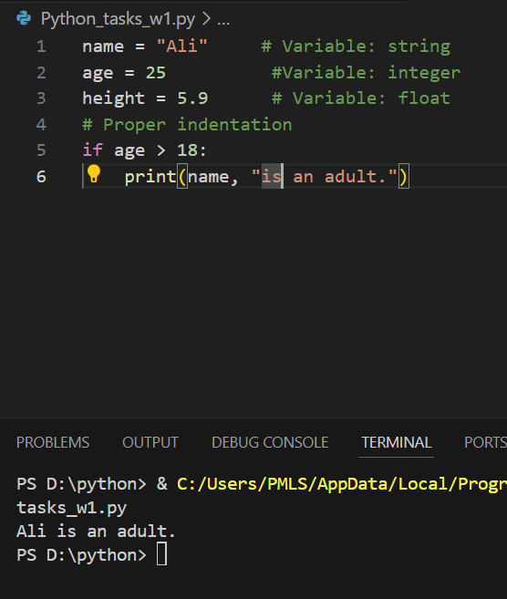

**3. Data Types**

**Task: Print different data types and check their type**

**Code:**

a = 10 # int

b = 3.14 # float

c = "Python" # str

d = True # bool

print(type(a), a)

print(type(b), b)

print(type(c), c)

print(type(d), d)

**Output**

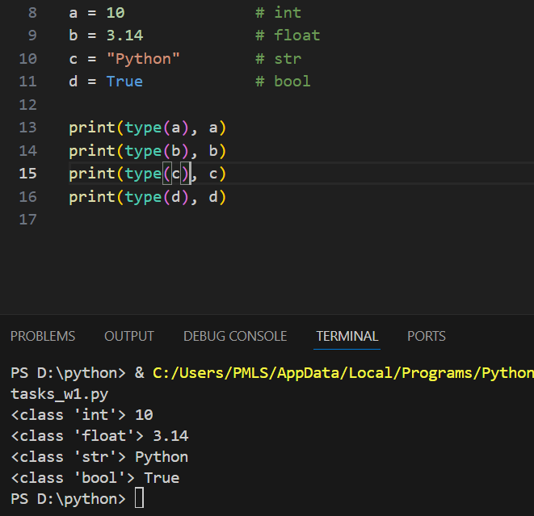

**4. Operators**

**Task: Use basic operators**

**Code:**

x = 8

y = 3

# Arithmetic

print(x + y, x - y, x \* y, x / y, x % y, x \*\* y)

# Comparison

print(x > y, x == y, x != y)

# Logical

a = True

b = False

print(a and b)

print(a or b)

print(not b)

**Output**

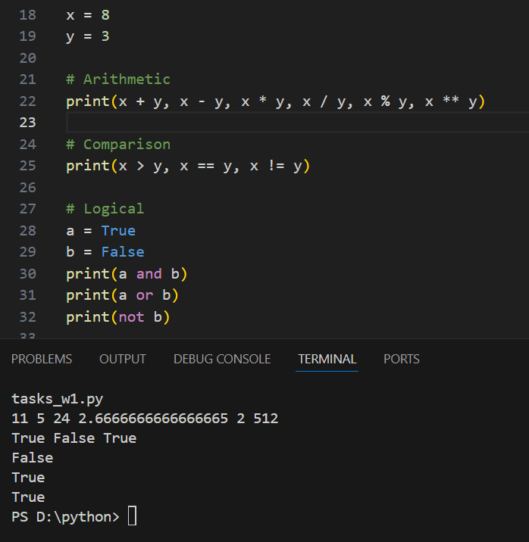

**5. Input/Output**

**Task: Take input and print results**

**Code:**

name = input("Enter your name: ")

age = int(input("Enter your age: "))

print("Hello", name, "- you are", age, "years old.")

**Output**

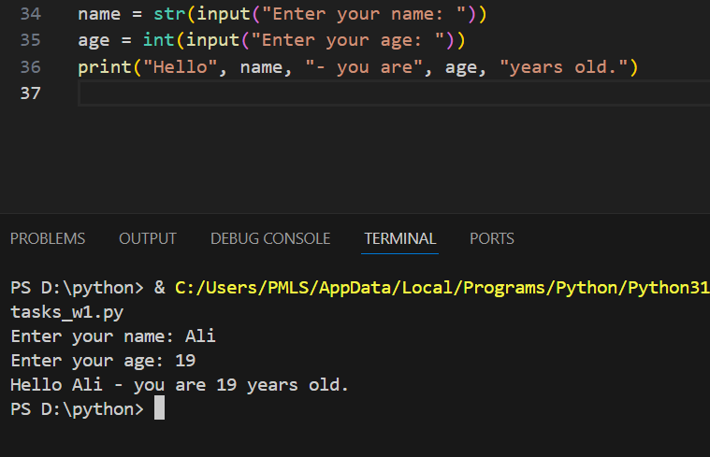

**6. Control Flow – Conditional Statements**

**Task: Use if, elif, and else**

**Code:**

marks = int(input("Enter your marks: "))

if marks >= 90:

print("Grade: A+")

elif marks >= 75:

print("Grade: A")

elif marks >= 60:

print("Grade: B")

else:

print("Grade: C or below")

**Output**

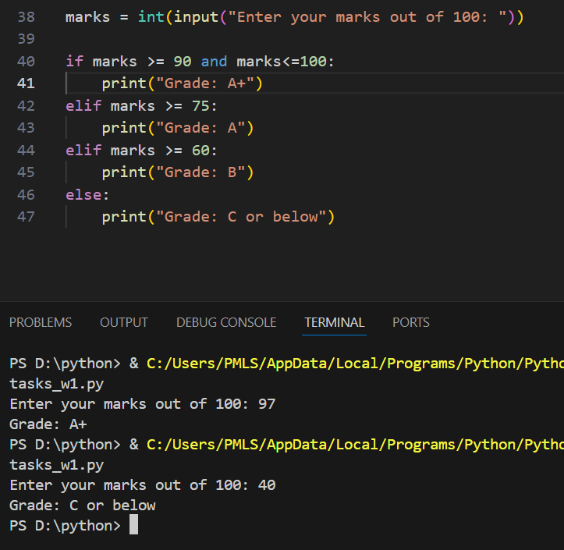

**7. Control Flow – Loops**

**Task: Practice loops with break, continue**

**Code:**

# for loop

for i in range(1, 6):

print("Number:", i)

# while loop

i = 1

while i <= 5:

if i == 3:

i += 1

continue # skip 3

print("While loop:", i)

i += 1

**Output**

